STAT 252 R3

LAB 2

DONG, Boyuan

STAT 252 Lab 2

1.

(a) It’s an experimental study, because the researcher applies different treatments to different subjects and observes the outcomes. The healthy group is the controlled group, It’s important because it plays a role as a normal sample compare to other treatment samples to see the differences and changes.

(b)

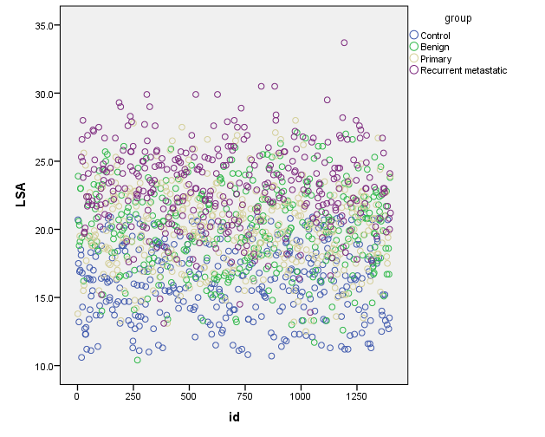

1. No, the plot does not indicate the time trend which would mean the presence of measurement bias.
2. If there are some patients with recurrent metastatic breast cancer were wrongly classified as benign or primary, the differences of LSA among different stages of breast cancer patients is less significant than it should be. The result of this study will show that the measurement of LSA is less important than it should be.

2.

(a)

Mean: µControl=16.135 < µBenign=20.086 < µPrimary=20.133 < µRecurrent Metastatic=23.150

SD: SDControl=0.1457 < SDPrimary=0.1562 < SDRecurrent Metastatic=0.1625 < SDBenign=0.1676

There’s a significant evidence suggest that individuals with breast cancer have higher LSA measures than healthy individuals as the breast cancers’ mean and SD of LSA is higher than the healthy people.

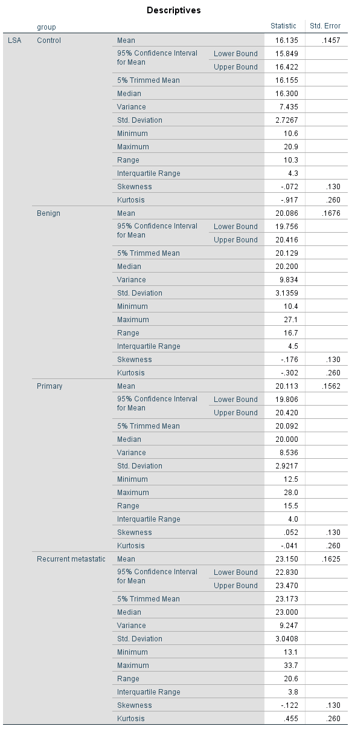]]jjjj

(b)

CI: Control=(15.849,16.422) Benign=(19.756,20.416) Primary=(19.806,20.420) Recurrent=(22.830,23.470)

The precision is 95% confidence interval for mean, at level of significant 0.025.

The intervals of Benign and Primary are overlapping.

(c)

Median: Recurrent Metastatic > Benign > Primary > Control

Spread: The spreads of four groups in the plot are almost the same

Shape: Recurrent Metastatic is a little right skewed

Primary is almost a normal distribution

Benign is almost normal with a little left skewed

Control is almost normal with a little left skewed

Outliers: Recurrent Metastatic has one outlier upside and a few outliers downside

Primary has no outliers

Benign has one outlier downside

Control has no outliers

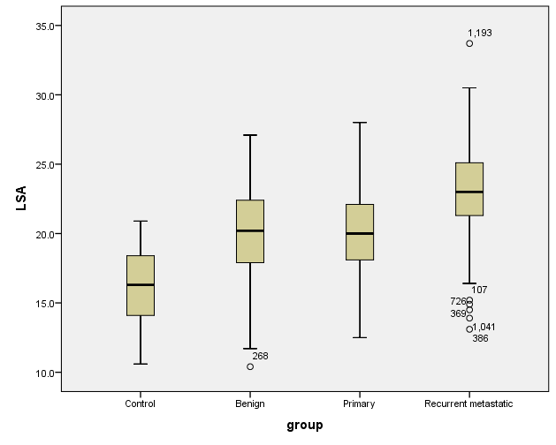

(d)

None of the plots suggesting a clear departure from normality.

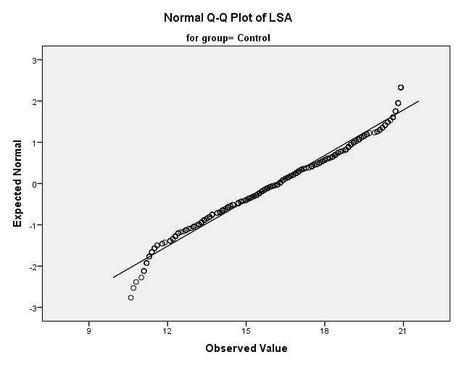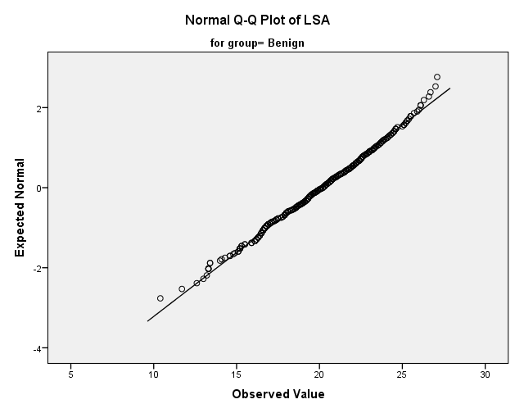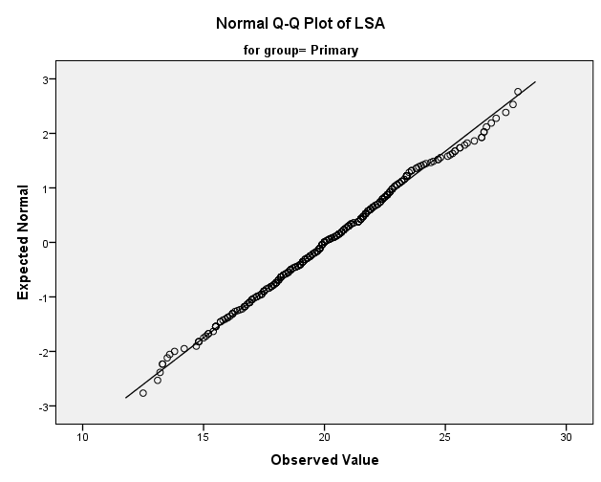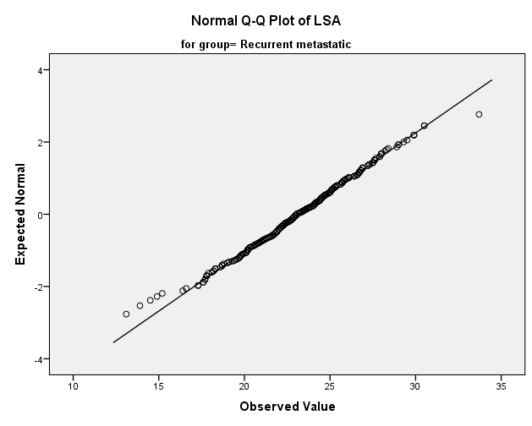

3.

(a)

H0: LSA measurements for the four groups are all the same. (µ1=µ2=µ3=µ4)

HA: there are some differences in LSA measurements of the four groups. (at least 2 µi are different)

Sum of square residuals:

Full: 12232.877

Reduce: 20916.794

Pooled estimate of variance: 8.763

F-statistic: 330.332

P-value: 0.000

As P-value=0.000, reject H0, we have enough evidence to suggest that there are some differences in LSA measurements of the four groups.

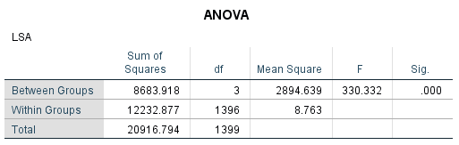

(b)

H0: σ1=σ2=σ3=σ4

HA: at least two of them are not equal

Since Levene’s test gives a large P-value (P = 0.218>0.05), the Levene’s test is not significant, indicating the H0 can’t be rejected, so the data support the assumption of equal variances.

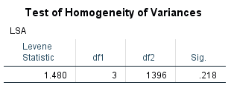

(c)

Extra sum of squares = residual sum of squares (reduced) – residual sum of squares (full) = 8683.918

Formula for F-statistic = ((Extra sum of squares) / (extra degrees of freedom)) / (Full variance) = ((8683.92) / (3)) / 8.763= 330.33

The distribution of null hypotheses with a degree of freedom of 1396.

4.

The results of two procedures are consistent.

Tukey HSD:

Out of 6 confidence intervals, 1 contain zero and 5 do not contain zero. Equivalently, in 1 case the test failed to establish a difference between the means. More precisely, there are significant differences between the Control and Benign, Control and Primary, Control and Recurrent metastatic, Benign and Recurrent metastatic, and Primary and Recurrent metastatic. (note the low p-value and the confidence interval NOT including zero)

Scheffe:

Out of 6 confidence intervals, 1 contain zero and 5 do not contain zero. Equivalently, in 1 case the test failed to establish a difference between the means. More precisely, there are significant differences between the Control and Benign, Control and Primary, Control and Recurrent metastatic, Benign and Recurrent metastatic, and Primary and Recurrent metastatic. (note the low p-value and the confidence interval NOT including zero)

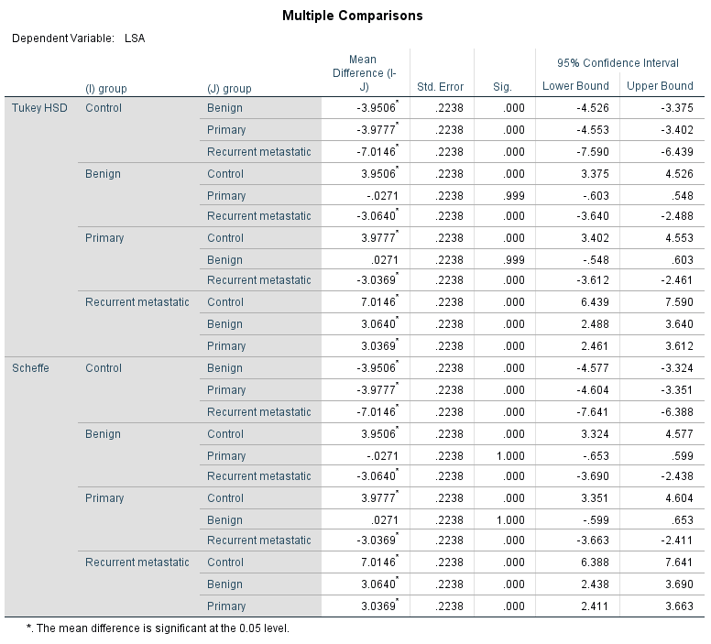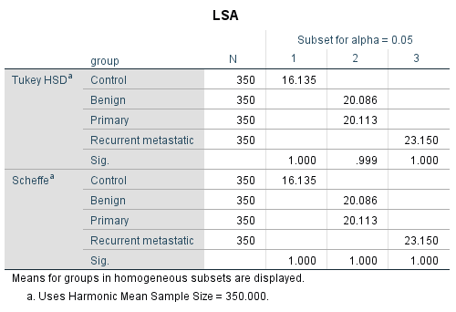.

5.

(a)

The contrast of interest is $μ1-(μ2+μ3+μ4)/3 = 0$ it equivalents as $3μ1-μ2-μ3-μ4=0$

H0: cancer patients have the same LSA from healthy individuals (The contrast of interest equal to 0)

HA: cancer patients have different LSA from healthy individuals (The contrast of interest does not equal to 0)

P-value: 0.000

In conclusion, p-value=0.000, reject H0, there are enough evidence to suggest that cancer patients have different LSA from healthy individuals.

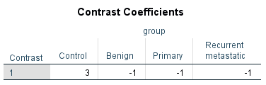

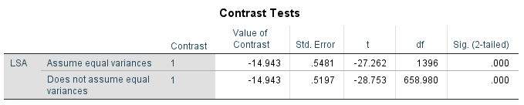

(b)

The contrast of interest is $μ4-\frac{μ2 + μ3}{2}= 0$ it equivalents as

H0: LSA measurements in metastatic breast cancer cases is the same as LSA levels in benign and primary breast cancer cases (The contrast of interest equal to 0)

HA: LSA measurements in metastatic breast cancer cases differ from LSA levels in benign and primary breast cancer cases (The contrast of interest not equal to 0)

P-value: 0.000

In conclusion, p-value=0.000 reject H0, there are enough evidence to suggest that LSA measurements in metastatic breast cancer cases differ from LSA levels in benign and primary breast cancer cases

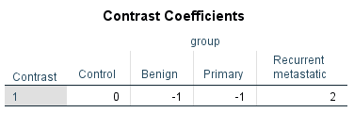

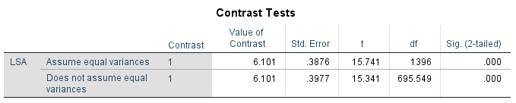

6.

We have enough evidence to suggest that there are some differences in LSA measurements of the four groups;

There is enough evidence to suggest that cancer patients have different LSA from healthy individuals;

There is enough evidence to suggest that LSA measurements in metastatic breast cancer cases differ from LSA levels in benign and primary breast cancer cases

The LSA level of cancer patients differs from healthy people, LSA level of metastatic breast cancer patients differs from Benign and Primary breast cancer patients, which is good for detecting and determine the breast cancer. However, the differences between Benign and Primary is not significant, the intervals between these two groups are overlapping. In the Tukey’s and Scheffe’s multiple-comparison procedures, confidence interval contains zero, the test between Benign and Primary failed to establish a difference between the means. So, LSA levels would not be effective for breast cancer detection.